For information only – not an official document

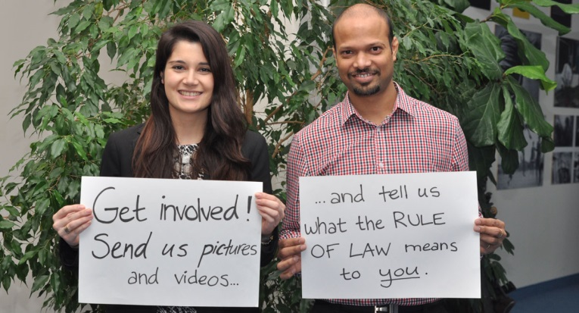
The Rule of law:
what does it mean to you?
Let us know what the rule of law means to you by posting a short video clip or a photo on Facebook, Instagram or Twitter using the hashtag #myruleoflaw. You can also send it to crimecongress[at]unvienna.org if you want us to upload it to the official Crime Congress platforms.

Get involved and check out our social media platforms

Website: http://www.un.org/en/events/crimecongress2015 Twitter account: @crimecongress13

Facebook: https://www.facebook.com/UNCrimeCongress2015 Instagram account: @crimecongress

‘It’s a crime’ campaign
Different crimes will be in focus, highlighting their links to sustainable development and telling their transnational story.

December: Human trafficking
January: Migrant smuggling
February: Weak governance and corruption/ Cybercrime
March: Wildlife and forest crime
April: How transnational organized crime prevents sustainable development

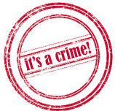

All mini-campaigns can be found under: http://www.unis.unvienna.org/unis/en/events/2015/crime_congress.html

Exploring the nexus between crime and development

The 13th United Nations Crime Congress brings together governments, policy-makers and experts to share their experiences and intensify international cooperation in tackling the threat of transnational organized crime. The Doha Congress will focus on links between security, justice and the rule of law, and the attainment of a better, more equitable world. There can be no sustainable development without effectively tackling crime and having respect for the rule of law.

Use the #crimecongress hashtag when posting to make it easier to follow all Crime Congress activities.

Email us any questions or to let us know about your activities: crimecongress@unvienna.org

